**Exp. 2 BASIC LOGIC OPERATIONS**

Engr 357 - Digital Design Lab

Fall 2015

Farnam Adelkhani

Sandra Hernandez

Date Experiment Performed: 9-3-2015

Date Report Submitted: 9-10-2015

FarnamAdelkhani

Sandra Hernandez

Engr 357 - Digital Design Lab – 9/7/15

Experiment #2

**Exp. 2 – BASIC LOGIC OPERATIONS**

**Abstract and Objective:**

Our main goal of experiment two is to become familiar by creating digital circuits using basic logic gates operations. Learning the properties of the logic gates AND, OR, NAND, NOR, XOR, XNOR and NOT inverters. In the lab manual we read how to convert the physical voltage levels to the abstract logic values the positive and negatives. Then we follow the instructions in the manual to start our experiment and learn how the basic logic operations using the lab kit provided.

**Components Used:**

Cadet II complete analog/digital electronics trainer complete with integrated breadboards

Probing Wires

Integrated Circuit (IC)

The following gates: 74LS00 74LS04 74LS08 74LS32 74LS86A

Logic Switches and Logic Monitor

**Procedures and result:**

1. Weconnected all the five ICs 74LS00, 74LS04, 74LS08, 74LS32, and 74LS86A in thebreadboard facingthe same direction. Letting one of the tops rows as the Vcc bus and the bottom row as the ground bus. We use many probe wires to carefully connect the ICs into the Vcc bus and the ground bus. We connected everything correctly as expected.
2. With the five ICs connectedin the breadboard we used only four of them to form the circuit describe in the manual. These four ICs have identical gates, pins 1 and 2 are the inputs and pin 3 is the output. With this information it was an easy to formed the circuit.
3. Keepingthe poweroff we connected the Vcc bus to a +5 V circuit. We used two toggle switches andfour lights. Each light connected with the corresponded ICs to complete and performedthe circuit.
4. Our results form the first circuit is shown in data table below. We double check the circuit to make sure every probe wire was in the right position and turn the power on to get started working with the circuit. If the red light turns on red means HIGH/ON and if the green light turnon green it means LOW/OFF.

|  |  |  |  |  |
| --- | --- | --- | --- | --- |
| x y | F1 | F2 | F3 | F4 |
| offoff | H | H | H | L |
| off on | L | L | H | L |
| on off | L | L | L | H |
| onon | H | L | L | H |

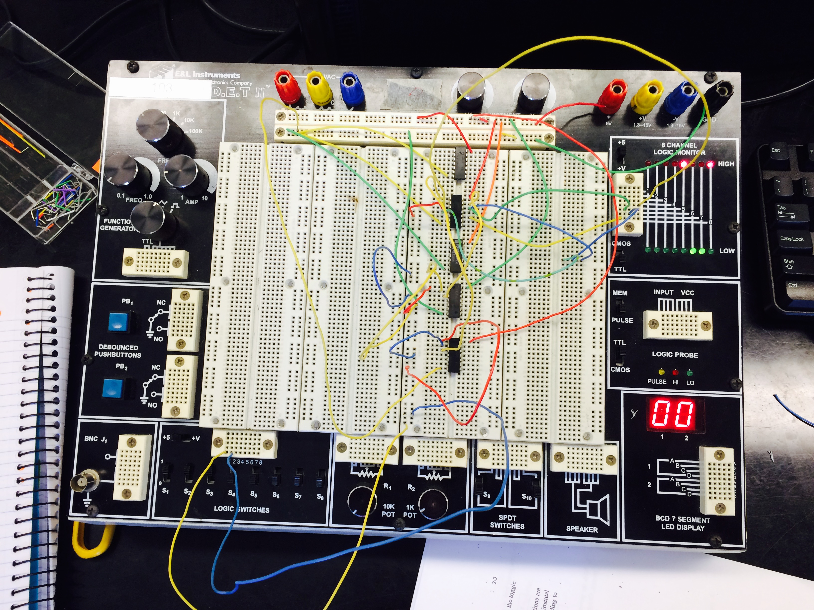5. In order to build the next circuit we removed all the probe wires except the ones connected in the Vcc and ground bus. Using three ICs we made the circuit as described but we had some trouble with the circuit. The ICs 74LS04 had some difference from the rests ICs We used probe wires to connect 74LS86A and 74LS32 and itself. But at the end we finally came up with our correct results that are shown in the data table

|  |  |  |
| --- | --- | --- |
| x y | F9 | F10 |
| off off | H | L |
| off on | H | H |
| on off | H | H |
| onon | H | L |

6. On our next circuit formed again we removed the probe wires an living the Vcc and ground bus connected. We used four ICs 74LS08, 74LS32, 74LS00, 74LS86A. We connected the four ICs using only two lights

|  |  |  |  |  |
| --- | --- | --- | --- | --- |
| x y | F5 | F6 | F7 | F8 |
| offoff | H | H | L | H |
| off on | L | L | L | H |
| on off | L | L | L | H |
| onon | H | L | L | H |

**Post lab and Conclusion**

We learned how the basic logic operation works using all our equipment. Getting started with the first connections was easy later on the next connections got a little bit of challenge with some failures on our results but we were able to make it work and get our correct answers. Also with a little help from our instructor helped us a lot to get our final. We were able to distinguish the result from each logic gates AND, NOT, NAND, NOR, OR, XOR, and XNOR. The experience learned from this lab was useful for our better understanding of the production of the logic gates.